**Answer Sheet - Python**

Name : Goldy kumar

Phone No. : 8351919540

Email : goldykumar250520000@gmail.com

**Major Question 1 15 Marks**

1. Write a program to print the following pattern :

*

* *

* * *

* * * *

* * *

* *

*

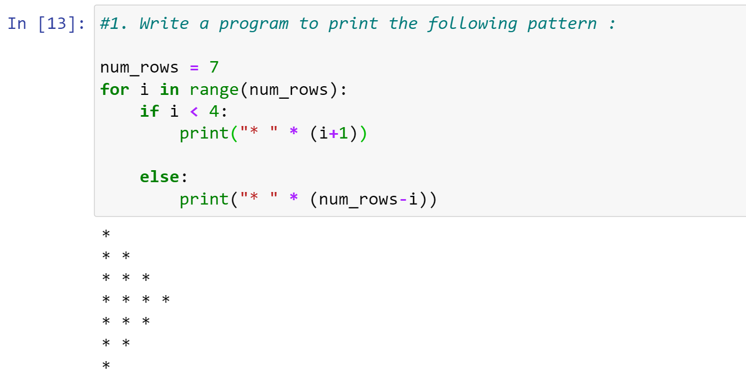

1. Write a program to accept 5 even and 5 odd numbers from the user and display

* *sum of even numbers,*
* *product of odd numbers*
* *absolute difference of the sum and product.*

Check if the *final result is a* *prime number or not.*

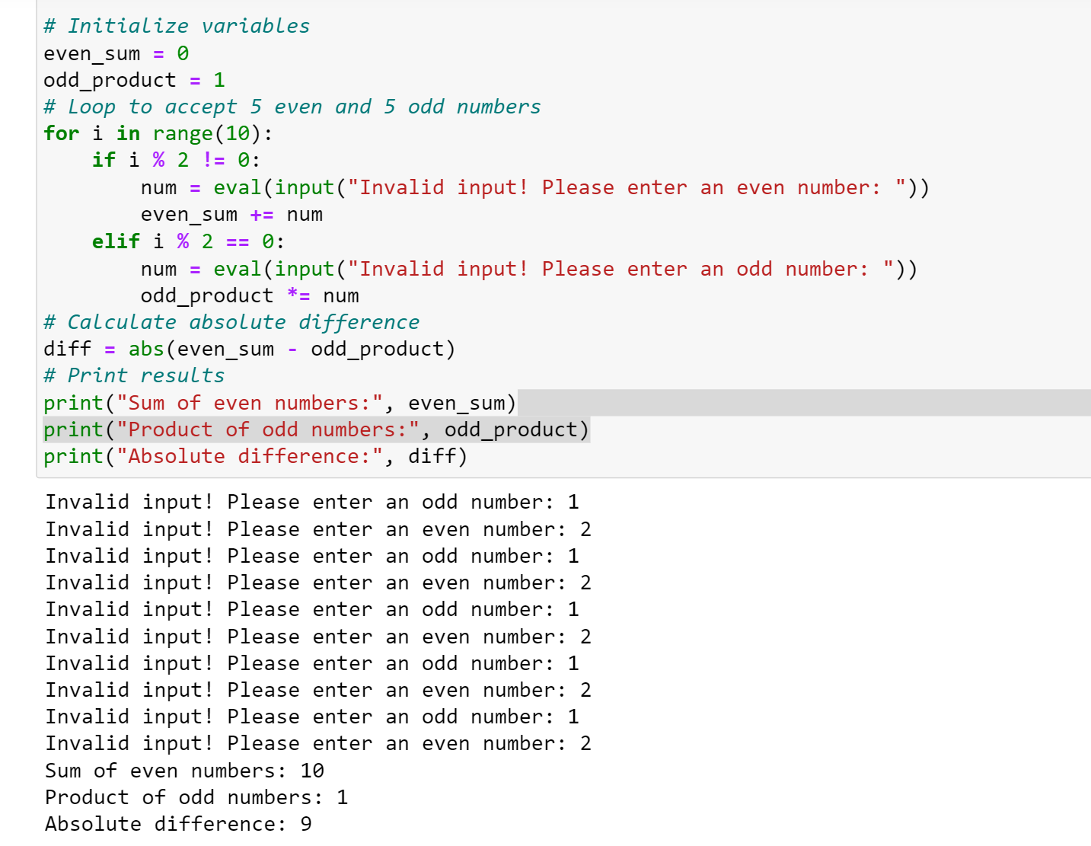

1. Create a class named Item that holds data about an item in a retail store. The class should have the following three properties:

* *name*: the name property is a String object that holds the name of the item.
* *price*: the price property is a double variable that holds the item's retail price
* *quantity*: the quantity property is an int variable that holds the number of units currently in inventory

Write four methods to retrieve the values from the three fields and their current inventory value

* *getName( )* returns the item name String
* *getPrice( )* returns the price of the item double
* *getQuantity( )* returns the number of quantities int
* *getValue( )* that returns the current inventory value (quantity * price) double

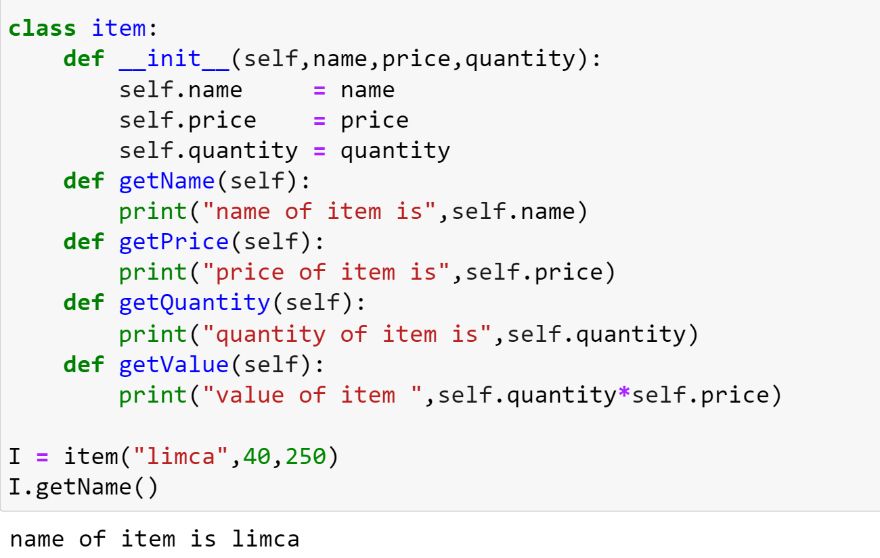

**Major Question 2 15 Marks**

1. Ask the user number of rows to be generated of a series. Suppose user enters no. of rows = 5 then the series shall be :

9

99

999

9999

99999

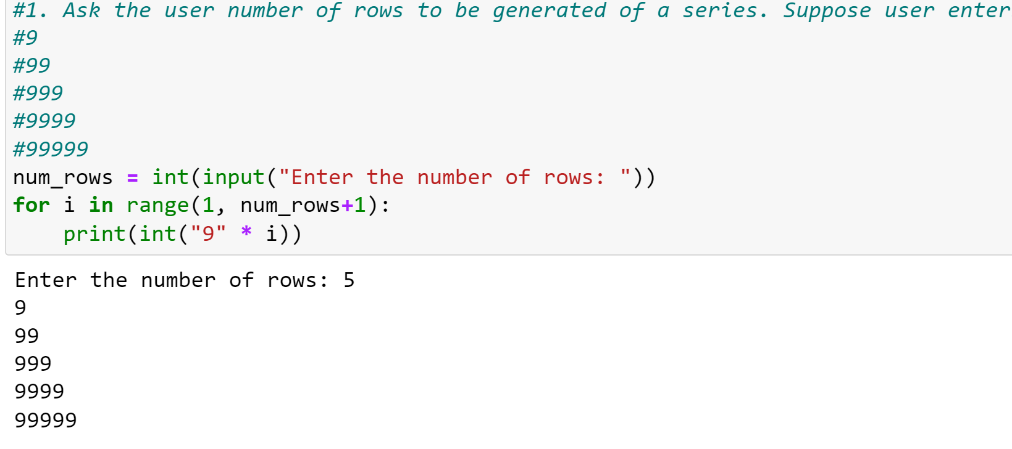

1. Write a program to accept a number from the user and check whether the number entered is prime or not.

<answer-here>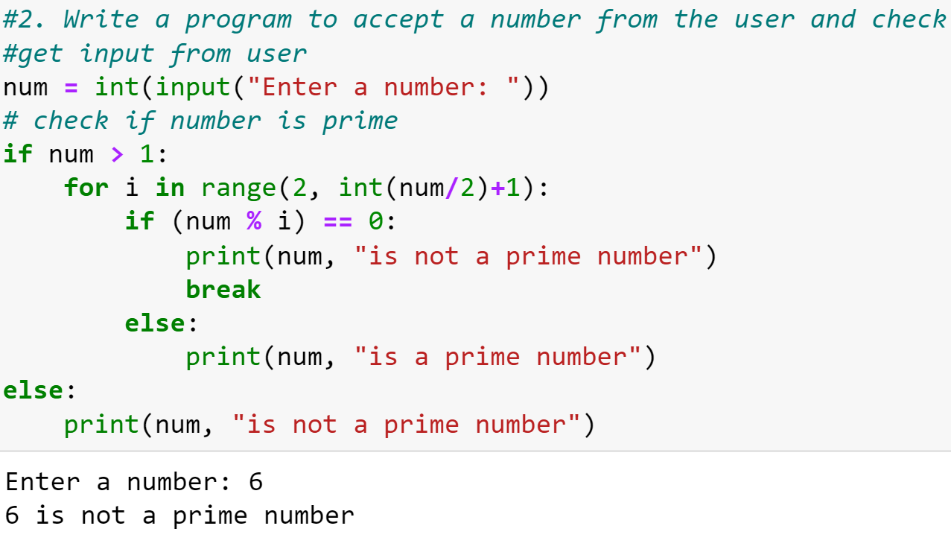

1. Continued from Major Question 1. Write a separate class called Inventory with methods

* *generate()* - creates three Item objects
* *getDetails()* - produces a neatly formatted table of the store's inventory displaying the three items, their current inventory value, and the total inventory value for the store.

